Frontend Research Document

In this document we are going to compare the 3 potential frontend frameworks for our semester project.

# Angular

## What is Angular?

Angular is a component based framework released by Google in September of 2016. It is a complete rewrite of AngularJS. (Wikipedia, 2021) Angular comes with a CLI which makes a number of tasks faster such as generating new components, compiling and running unit tests. (Google, 2021)

### Competitors of Angular

The main competitors of Angular are the other 2 most popular Javascript frameworks: Vue and React . Looking at the job listings in 2019 we can see a graph from the most job listed for these frameworks (Elliot, 2020)

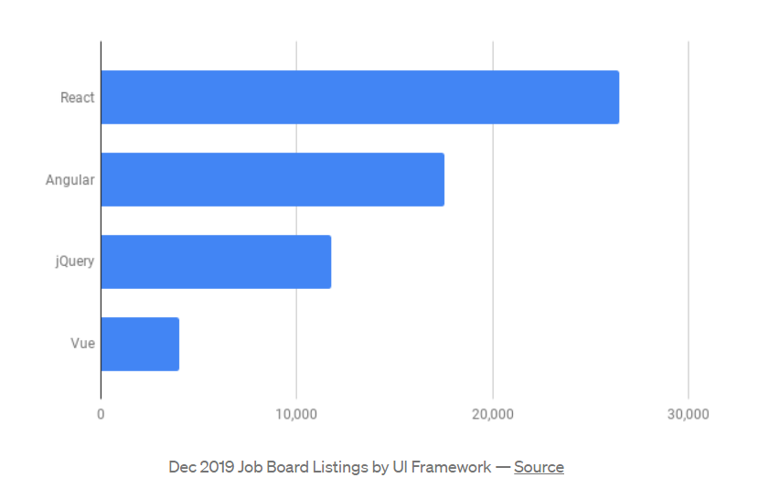

The following graph shows the available job openings for the 3 frameworks based on popular job listing websites (Daityari, 2021)

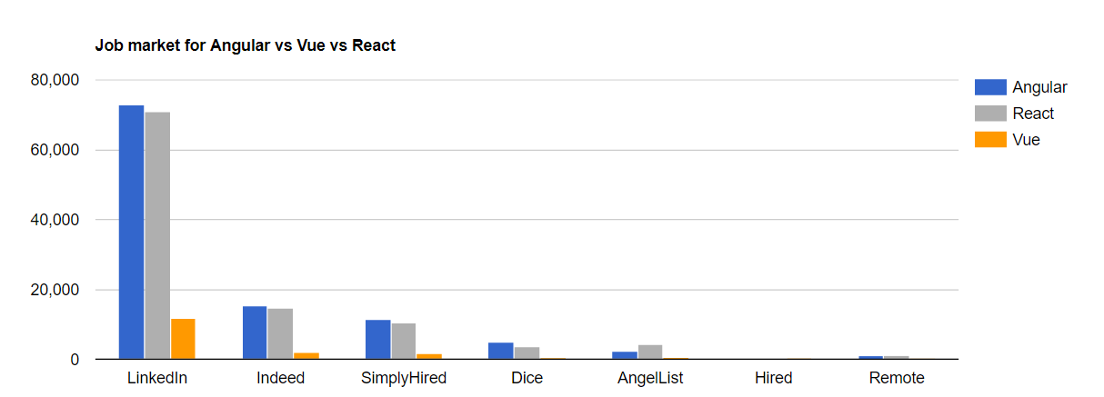

## Why Angular?

Angular is supported by Google, the biggest search engine in the world, has extensive documentation because it is a complex framework intended for large scale use.

Although it might be harder to learn in the beginning than React or Vue and it has a steeper learning curve, it is an all in one framework allowing the creation of hybrid mobile apps, progressive web apps with good web standards and impressive performance even though on heavier application React or Vue might be faster (Borrelli, 2021)

### Typescript

Angular strongly recommends using TypeScript instead of HTML or JSX which may deter some developers, particularly the ones that already know another framework and are not willing to learn TypeScript as well. Angular chose TypeScript because it is nothing more than JavaScript with additional features. These features include simplifying code, easier to read code, open source, functions with optional parameters and functions with REST parameters. (Sharma, 2018)

# Vue

## What is Vue？

Vue.js was developed by Evan You when he was working at Google making numerous prototypes right within a browser using AngularJS. He extracted the favorite parts from Angular and adapted them, and finally released the first version of Vue in 2014.(Wikipedia, 2021) Vue is a growing framework for building user interfaces and single page applications. The difference between Vue and other frameworks is that Vue is designed to be applied layer by layer from the bottom to up. Vue's core library only focuses on the view layer, which is not only easy to use, but also easy to integrate with third-party libraries or existing projects. At the same time, Vue is also adaptive for complex one-page applications when used in combo with proper tooling and libraries. (Mamani, 2019)

## Competitors of Vue

There are two main competitors of Vue: Angular and React. The line chart below shows the number of stars that their GitHub repositories get. The number of stars in Vue has grown rapidly since 2016 and surpassed React in 2018，marking Vue among the most popular frameworks. (Daityari, 2021)

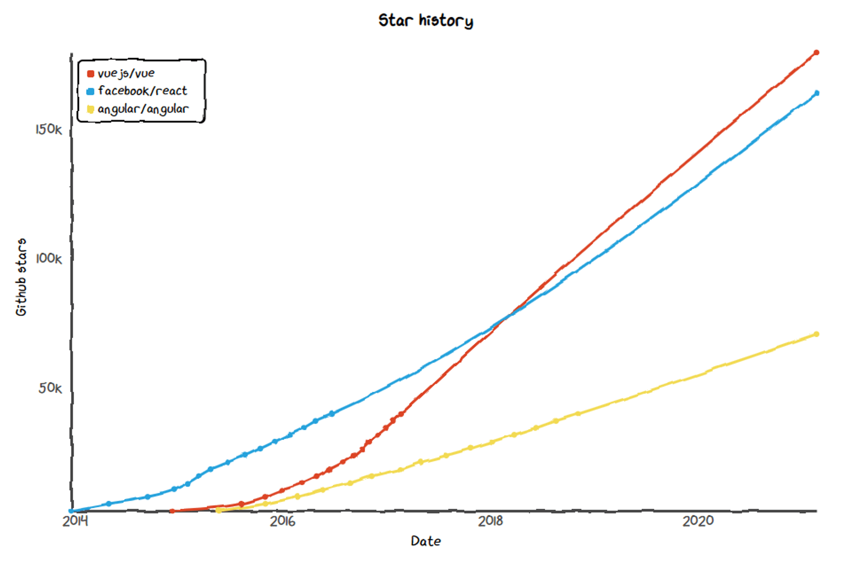

## Why Vue?

Vue is the newest of the top three JavaScript frameworks. In terms of features Vue comes as a more complete package and is taking the middle ground between React’s open source supported extensions and Angular’s all-in-the-box list of features. Vue separates the HTML page templates from the JavaScript logic similar to the Angular framework with the advantage of it using as close to vanilla JavaScript and HTML as possible. This helps define the Vue frameworks as the easiest to get into and learn for developers who are already used to working with basic JavaScript and HTML. Another advantage of Vue is the fact that the complexity of the setup when starting a new project with Vue is dependent on the project’s size and goals. In terms of performance Vue’s startup and runtime performance is on par with Angular and React’s performances.

# React

## What is React?

React is a JavaScript frontend library that is designed to help build user interfaces and UI components.

It was created by a software engineer at Facebook called Jordan Walke. (Wikipedia, 2021)

## A brief history

#### How did React start

React was developed by Facebook and was released on 29 May 2013, making it a middle child among the 3 competitors. React is used by Facebook in every product, like on WhatsApp and Instagram besides Facebook itself. The current stable version is 17.X, released just a month before the latest angular version was released in 2020.

#### License

React Uses MIT license. What is an MIT License? A joint project organized between IBM, MIT, and DEC in 1983 gave birth to MIT license. MIT License is one of the simplest open source license agreements. The intention after the MIT license was to avoid extensive litigation, which may have arisen from other similar Free and Open-Source Software (FOSS) licenses.

MIT license allows users to reuse a code for any purpose if the original copy of the MIT license is included in their distribution. They can also make any changes to the code according to their necessity.

#### Popularity

React is the most popular front-end library after j-query. As word react is used in daily vocabulary it is difficult to grasp popularity from any trend’s website, but stars in react git repos can be one of the proxies to judge about the popularity. As per react they have over 150K starts in git repos which makes it popular.

#### Job market research (only for the Netherlands)

React has a big footprint in the job market. The biggest job searching websites like LinkedIn, Indeed.nl and simplyHired.nl shows that there are at least 1,500 jobs which need react.js requirements. This is just for react.js and if you are looking for native there are at least 500 more jobs in the market.

#### Community and development

React has one of the biggest communities. The latest version was released in October 2020 which means people are busy with the development. From the GitHub’s “Used By” badge which should be enabled by the author, this showed how many other repos were depending on that repo. React shows over 5,7 million users currently working in React. This number is the highest than any other framework.

#### 

#### Migrations

Working on frameworks, you don’t want to change a significant amount of code in each release or after every version. So, migration can be one of your biggest concerns while you choose one of the frameworks. Sometimes you need to keep your finger crossed, so that your code will be still working after the update even though every framework update is announced well in advance.

While working in React you don’t have to worry about these things because Facebook has announced that stability is of utmost importance to them. Some of the giant companies are using react because script such as react-codemod helps you migrate very easily.

### Who uses React?

React is used by many leading technology brands, including Facebook, Twitter, Uber, Netflix, Tumblr, Walmart, PayPal, Reddit and Udemy. (Kumar, 2021)

### Competitors of React

The biggest competitors of React are Vue and Angular.

#### Vue

Vue originally was a JavaScript frontend framework that was released in 2014. It was created by Evan You. It has picked up in popularity significantly since 2016. Surpassing React at usage counts in 2018. Since 2020, Vue 3.0 has been released which made Vue a TypeScript framework instead.

#### Angular

Angular was released in 2016. It is based on TypeScript and a full-fledged framework. Regulated and maintained by Google. It has been steadily growing in popularity since it’s release but still is significantly behind react and Vue in popularity.

### Why React over Vue or Angular?

For the answer of our main topic, we have to look at what React has to offer which Vue or Angular does not have.

#### React over Angular

First, we will start by deciding why we want React over Angular.

React is a JavaScript library compared to angular which is a TypeScript complete framework.

This leads to a bigger learning curve. Even though Angular has more to offer. As this is our semester project, we do not believe the team has the time to learn TypeScript and a framework as big as Angular.

To conclude, React will fit our needs as it is lightweight and doesn’t have a steep learning curve.

#### React over Vue

Lastly we will give our reasoning on why we will use React over Vue.

As of 2020 Vue has become a TypeScript framework which like Angular will result in a steeper learning curve compared to React.

Also like Angular Vue is a full fledged framework unlike React which is a library. Resulting in easier handling.

The Vue community is growing but still lacks the maturity of React’s. Leading to less sources and troubleshooting compared to React.

To conclude, due to React offering more sources and having a smaller learning curve we decided to go with React over Vue.

## 

### Conclusion

As the reasons have been given in the above section, we conclude by choosing React as our frontend framework.

We will believe it will fit our needs, and prove to be a reliable frontend framework.

**Bibliography**

Borrelli, P. (2021, 1 11). Angular vs. Vue vs. React: Comparing frameworks by performance. https://blog.logrocket.com/. <https://blog.logrocket.com/angular-vs-react-vs-vue-a-performance-comparison/>

Daityari, S. (2021, 3 15). Angular vs React vs Vue: Which Framework to Choose in 2021. <https://www.codeinwp.com>

<https://www.codeinwp.com/blog/angular-vs-vue-vs-react/>

Elliot, E. (2020, 12 4). Top JavaScript Frameworks and Topics to Learn in 2020 and the New Decade. Medium.com. <https://medium.com/javascript-scene/top-javascript-frameworks-and-topics-to-learn-in-2020-and-the-new-decade-ced6e9d812f9>

Google. (2021, 3 8). Angular. What is Angular. Retrieved 3 18, 2021, from <https://angular.io/guide/what-is-angular>

Sharma, A. (2018, 10 10). Why You Should Use TypeScript for Developing Web Applications. Web Dev Zone. Retrieved 3 18, 2021, from <https://dzone.com/articles/what-is-typescript-and-why-use-it>

Wikipedia. (2021, 3 9). Angular (web framework). Wikipedia. Retrieved 3 18, 2021, from <https://en.wikipedia.org/wiki/Angular_(web_framework)>

Daityari, S. (2021, March 15). *Angular vs React vs Vue: which Framework to Choose in*

*2021*. codeinwp. Retrieved March 18, 2021, from

<https://www.codeinwp.com/blog/angular-vs-vue-vs-react/>

Mamani, M. L. (2019, November 26). *What is Vue.js and How do we Use it?* Avantica.

Retrieved March 18, 2021, from

<https://www.avantica.com/blog/what-is-vue.js-and-how-do-we-use-it>

React vs. Angular vs. Vue: Which Should You Choose? (2018, June 29). [Video file].

Retrieved March 18, 2021, from

<https://www.youtube.com/watch?v=xDhzYQ4VyCw&ab_channel=Treehouse>

Angular vs React vs Vue [2020 Update]. (2020, March 19). [Video file].

Retrieved March 18, 2021, from

<https://www.youtube.com/watch?v=lYWYWyX04JI&t=110s&ab_channel=Academind>

Wikipedia contributors. (2021, March 21). React (JavaScript library). In *Wikipedia, The Free Encyclopedia*.

Retrieved 15:39, March 23, 2021, from

<https://en.wikipedia.org/w/index.php?title=React_(JavaScript_library)&oldid=1013367584>

Wikipedia contributors. (2021, March 15). Vue.js. In *Wikipedia, The Free Encyclopedia*.

Retrieved 15:40, March 23, 2021, from

<https://en.wikipedia.org/w/index.php?title=Vue.js&oldid=1012283657>

Kumar, A. (2021, March 1). React vs. Angular vs. Vue.js: A Complete Comparison Guide.

Retrieved March 23, 2021 from

<https://dzone.com/articles/react-vs-angular-vs-vuejs-a-complete-comparison-gu>

Kuts, R. (2020, January 12). React vs Angular vs Vue.js. What Is the Best Choice in 2021.

Retrieved March 23, 2021, from

<https://blog.techmagic.co/reactjs-vs-angular-vs-vuejs-what-to-choose-in-2020/>